
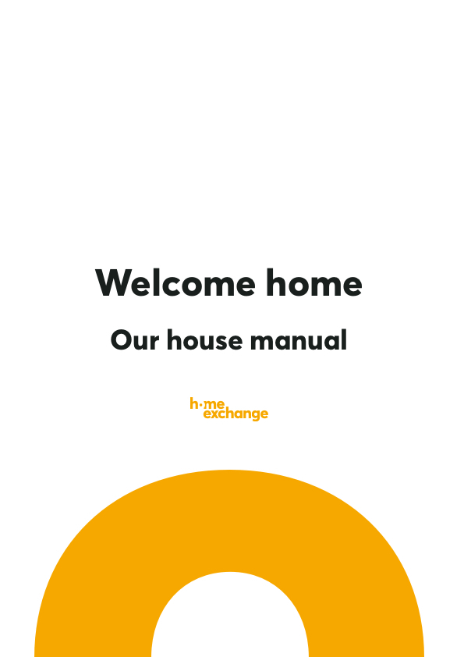

Table of contents
- Who we are
1.1 Let me present myself
1.2 Our pets
1.3 A tour of our home

- Practical information
2.1 Emergency numbers
2.2 Useful codes to have
2.3 The to-do list
2.4 How to use the products we have at home
2.5 Others
2.6 Some house rules

- Our recommendations
3.1 Where to eat - our recommendations!
3.2 Where to buy things -our neighbourhood stores
3.3 Some other things-to-do

- Some parting words

Welcome to The …....……………………...……

Our home is now also your home.

Add a photo of your home

You’re arrived at (add address) …………………………………………………………
………………………………………………………....

You can reach us by phone: …………………………..…………………………...
Don’t hesitate to let us know when you’ve arrived and if there’s anything you need during your stay!

1. WHO WE ARE

1.1 Who’s that?
A photo of you (and your partner)

A photo of your family

From left to right, you have ……………………………………..………………………………………………………………………………….. ………………………………………………..………………………………………………..………………………………………………..…………………………………….

Our ages: …………………………………………………………………………………………………….…………………………………………………………….

1.2 Our furry (or not) friends

We present to you …………………………………………………………………………………………………………………………………………

His/her/their diet (allergies, food they can’t have, frequency of meals, etc.) ………………………………………………..………………………………………………..………………………………………………..…………………………………….………………………………………………..………………………………………………..………………………………………………..…………………………………….
………………………………………………..………………………………………………..………………………………………………..…………………………………….

How social they are : .………………………………………………………………………………....

1.3 A tour of our home
On the ground floor, you’ll find

The kitchen: (specify the available shelves for your guests, the private cupboards, what your guests can help themselves to, things that they need to be careful with, where to find the coffee and tea, etc.)
………………………………………………..………………………………………………..………………………………………………..…………………………………….………………………………………………..………………………………………………..………………………………………………..…………………………………….………………………………………………..………………………………………………..………………………………………………..…………………………………….………………………………………………..………………………………………………..………………………………………………..…………………………………….………………………………………………..………………………………………………..………………………………………………..…………………………………….………………………………………………..………………………………………………..………………………………………………..…………………………………….
- About the biscuits, snacks, available food, hygiene products in the bathroom, etc.: if you use them in moderation and replace what you finished, you can help yourselves to them
(Tick this option if it applies for you)
- Help yourselves to everything
(Tick this option if it applies for you)
- I would like to find my cupboards and pantry as it was when I left (so please replace what you used)
(Tick this option if it applies for you)

The living room: (specify which remote control is for what. For example: the black remote control is for Netflix, the grey is for the television, X is for the DVD player, Y is for the internet box, etc. indicate what they should do if they want to watch a DVD and any other information they might need.)
………………………………………………..………………………………………………..………………………………………………..…………………………………….………………………………………………..………………………………………………..………………………………………………..…………………………………….………………………………………………..………………………………………………..………………………………………………..…………………………………….………………………………………………..………………………………………………..………………………………………………..…………………………………….

If you have several remote controls (for the gate, the shutters, a lamp), do not forget to specify their use with a label or to put a photo in this guide along with what they are for. Here’s an example:

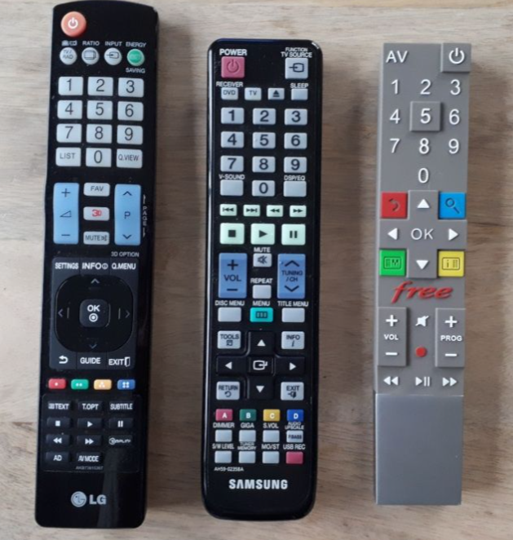

The big black remote control is used to turn on the TV. Press several times on "input" (top right) to switch to the freebox (HDMI1), the console (HDMI1) or the computer (HDMI1).

The small black remote control is used to manage the sound (home cinema displays D-IN to have the sound from the TV).

The grey remote control is used to turn on the cable box. That’s how we have access to the TV channels.

Be careful! If the sound does not work, turn everything on again in the following order: TV, Sound, cable box, and make sure the DVD button on the top left is on.

The remote controls are located in the drawer of the coffee table.

The dining room: (Indicate if there are any particular dishes that you do not want your guests to use, where to find the tablecloths, etc.)
………………………………………………..………………………………………………..………………………………………………..…………………………………….………………………………………………..………………………………………………..………………………………………………..…………………………………….………………………………………………..………………………………………………..………………………………………………..…………………………………….………………………………………………..………………………………………………..………………………………………………..…………………………………….

The master bedroom: (indicate where to find clean sheets, towels, etc. for the end of the stay)

………………………………………………..………………………………………………..………………………………………………..…………………………………….………………………………………………..………………………………………………..………………………………………………..…………………………………….………………………………………………..………………………………………………..………………………………………………..…………………………………….………………………………………………..………………………………………………..………………………………………………..…………………………………….

Another room: ………………………………………………..………………………………………………..………………………………………………..…………………………………….………………………………………………..………………………………………………..………………………………………………..…………………………………….

Another room: ………………………………………………..………………………………………………..………………………………………………..…………………………………….………………………………………………..………………………………………………..………………………………………………..…………………………………….

On the other levels, you’ll find

The bathroom: (indicate where your guests can find clean towels, extra toilet paper, etc.) ………………………………………………..………………………………………………..………………………………………………..…………………………………….………………………………………………..………………………………………………..………………………………………………..…………………………………….

X’s room: (indicate if there are any toys available, which shelves your guests can use)
………………………………………………..………………………………………………..………………………………………………..…………………………………….………………………………………………..………………………………………………..………………………………………………..…………………………………….

Y’s room: (indicate if there are any toys available, which shelves your guests can use)
………………………………………………..………………………………………………..………………………………………………..…………………………………….………………………………………………..………………………………………………..………………………………………………..…………………………………….

Another room:
………………………………………………..………………………………………………..………………………………………………..…………………………………….………………………………………………..………………………………………………..………………………………………………..…………………………………….

2. PRACTICAL INFORMATION

2.1 Numbers in case you need help
In addition to ours, which, as a reminder, is : ……………………………………..
……………………………………..

Here are some other numbers you can contact in case you need help:

Our neighbours:
Mr / Mrs………………… : ……………………………
Mr / Mrs ………………… : ……………………………

Our cleaning assistant: ……………………

Family/friends living in proximity:
Mr / Mrs………………… : ……………………………
Mr / Mrs………………… : ……………………………
Mr / Mrs………………… : ……………………………
Mr / Mrs………………… : ……………………………

Emergency numbers :
Police: …………….
Ambulance: …………….
Firetruck: …………….

In case of medical problems: (indicate the doctors, dentists, vets near where you live)
………………………………………………..………………………………………………..………………………………………………..…………………………………….………………………………………………..………………………………………………..………………………………………………..…………………………………….………………………………………………..………………………………………………..………………………………………………..…………………………………….………………………………………………..………………………………………………..………………………………………………..…………………………………….………………………………………………..………………………………………………..………………………………………………..…………………………………….

2.2 The passwords and codes

The codes to access the house:
………………………………………………..………………………………………………..………………………………………………..…………………………………….………………………………………………..………………………………………………..………………………………………………..…………………………………….

The WiFi name: ……………………………………………………………………………

The WiFi password: ……………………………………………………………………………

The portal code: …………………………………………………………………………

Other important codes:
………………………………………………………………………………………………………

………………………………………………………………………………………………………

………………………………………………………………………………………………………

2.3 The to-do list

During the stay
Incoming mail
………………………………………………..………………………………………………..………………………………………………..…………………………………….………………………………………………..………………………………………………..………………………………………………..…………………………………….

Plants that need watering
………………………………………………..………………………………………………..………………………………………………..…………………………………….………………………………………………..………………………………………………..………………………………………………..…………………………………….

Taking out the trash (how they should be sorted, which days do the garbage trucks come round, etc.)
………………………………………………..………………………………………………..………………………………………………..…………………………………….………………………………………………..………………………………………………..………………………………………………..…………………………………….

Any other instructions
………………………………………………..………………………………………………..………………………………………………..…………………………………….………………………………………………..………………………………………………..………………………………………………..…………………………………….

At the end of the stay
What to do with the sheets and towels (to be put in the washing machine/to be replaced with clean ones/to be left by the side of the bed...)
………………………………………………..………………………………………………..………………………………………………..…………………………………….………………………………………………..………………………………………………..………………………………………………..…………………………………….

Where to leave the keys (on the table/in the letterbox/with the neighbours...)
………………………………………………..………………………………………………..………………………………………………..…………………………………….………………………………………………..………………………………………………..………………………………………………..…………………………………….
Cleaning (indicate what you expect from your guests. Members usually ask that their home is left the way their guests found it.)
………………………………………………..………………………………………………..………………………………………………..…………………………………….………………………………………………..………………………………………………..………………………………………………..…………………………………….………………………………………………..………………………………………………..………………………………………………..…………………………………….………………………………………………..………………………………………………..………………………………………………..…………………………………….

2.4 How to use the products we have at home
Because each appliance has its specificities, here’s a guide for all of them.
(You can remove any section that is irrelevant for your home)

The dishwasher (you can indicate your preferred settings as well as which buttons should be pressed to get it going)
………………………………………………..………………………………………………..………………………………………………..…………………………………….………………………………………………..………………………………………………..………………………………………………..…………………………………….………………………………………………..………………………………………………..………………………………………………..…………………………………….

The washing machine/dryer (you can indicate the most useful settings and where to find the detergents)
………………………………………………..………………………………………………..………………………………………………..…………………………………….………………………………………………..………………………………………………..………………………………………………..…………………………………….………………………………………………..………………………………………………..………………………………………………..…………………………………….

The coffee machine (you can include a reminder to check the water levels, where to find the coffee capsules, etc.)
………………………………………………..………………………………………………..………………………………………………..…………………………………….………………………………………………..………………………………………………..………………………………………………..…………………………………….………………………………………………..………………………………………………..………………………………………………..…………………………………….

The oven (you can indicate the most useful functions)
………………………………………………..………………………………………………..………………………………………………..…………………………………….………………………………………………..………………………………………………..………………………………………………..…………………………………….………………………………………………..………………………………………………..………………………………………………..…………………………………….

The microwave
………………………………………………..………………………………………………..………………………………………………..…………………………………….………………………………………………..………………………………………………..………………………………………………..…………………………………….

The swimming pool (How to check the water filter, how to set up the robot cleaner, et.c Take the time to share all the important information to avoid any unpleasant surprises. You can also send a photo or a video to your guests showing clearly what to do to guide them along.)
………………………………………………..………………………………………………..………………………………………………..…………………………………….………………………………………………..………………………………………………..………………………………………………..…………………………………….………………………………………………..………………………………………………..………………………………………………..…………………………………….

Air-conditioning
………………………………………………..………………………………………………..………………………………………………..…………………………………….………………………………………………..………………………………………………..………………………………………………..…………………………………….………………………………………………..………………………………………………..………………………………………………..…………………………………….

Heaters
………………………………………………..………………………………………………..………………………………………………..…………………………………….………………………………………………..………………………………………………..………………………………………………..…………………………………….………………………………………………..………………………………………………..………………………………………………..…………………………………….

Add any other another appliance
………………………………………………..………………………………………………..………………………………………………..…………………………………….………………………………………………..………………………………………………..………………………………………………..…………………………………….………………………………………………..………………………………………………..………………………………………………..…………………………………….

Add any other another appliance
………………………………………………..………………………………………………..………………………………………………..…………………………………….………………………………………………..………………………………………………..………………………………………………..…………………………………….………………………………………………..………………………………………………..………………………………………………..…………………………………….

2.5 Others
(Where to find the keys to the letterbox, cleaning products, medications, bandages, extra blankets, utensils for the barbeque, etc.)
………………………………………………..………………………………………………..………………………………………………..…………………………………….………………………………………………..………………………………………………..………………………………………………..…………………………………….………………………………………………..………………………………………………..………………………………………………..…………………………………….………………………………………………..………………………………………………..………………………………………………..…………………………………….………………………………………………..………………………………………………..………………………………………………..…………………………………….………………………………………………..………………………………………………..………………………………………………..…………………………………….………………………………………………..………………………………………………..………………………………………………..…………………………………….………………………………………………..………………………………………………..………………………………………………..…………………………………….………………………………………………..………………………………………………..………………………………………………..…………………………………….………………………………………………..………………………………………………..………………………………………………..…………………………………….

2.6 Some house rules
(Remove the shoes once you enter the home, no smoking indoors, etc.)
………………………………………………..………………………………………………..………………………………………………..…………………………………….………………………………………………..………………………………………………..………………………………………………..…………………………………….………………………………………………..………………………………………………..………………………………………………..…………………………………….………………………………………………..………………………………………………..………………………………………………..…………………………………….………………………………………………..………………………………………………..………………………………………………..…………………………………….………………………………………………..………………………………………………..………………………………………………..…………………………………….………………………………………………..………………………………………………..………………………………………………..…………………………………….………………………………………………..………………………………………………..………………………………………………..…………………………………….………………………………………………..………………………………………………..………………………………………………..…………………………………….………………………………………………..………………………………………………..………………………………………………..…………………………………….

3. SOME RECOMMENDATIONS...

To travel like a local and immerse yourself in the culture and life !
If possible, share the public transport map with your guests.

3.1 Where to dine
Share with them your favorite spots!

………………………………………………..………………………………………………..………………………………………………..…………………………………….………………………………………………..………………………………………………..………………………………………………..…………………………………….………………………………………………..………………………………………………..………………………………………………..…………………………………….………………………………………………..………………………………………………..………………………………………………..…………………………………….………………………………………………..………………………………………………..………………………………………………..…………………………………….………………………………………………..………………………………………………..………………………………………………..…………………………………….………………………………………………..………………………………………………..………………………………………………..…………………………………….………………………………………………..………………………………………………..………………………………………………..…………………………………….

3.2 Where to shop
Recommend some local markets (with days and times), some small grocery stores, your favorite bakeries, etc.
………………………………………………..………………………………………………..………………………………………………..…………………………………….………………………………………………..………………………………………………..………………………………………………..…………………………………….………………………………………………..………………………………………………..………………………………………………..…………………………………….………………………………………………..………………………………………………..………………………………………………..…………………………………….………………………………………………..………………………………………………..………………………………………………..…………………………………….………………………………………………..………………………………………………..………………………………………………..…………………………………….………………………………………………..………………………………………………..………………………………………………..…………………………………….………………………………………………..………………………………………………..………………………………………………..…………………………………….

3.3. Things to do in the region
Recommend hiking trails, a place not to be missed near your home... Help your guests create an unforgettable vacation with your suggestions! Don't hesitate to stop by the local tourist office and take some brochures with you to leave with your guests!

………………………………………………..………………………………………………..………………………………………………..…………………………………….………………………………………………..………………………………………………..………………………………………………..…………………………………….………………………………………………..………………………………………………..………………………………………………..…………………………………….………………………………………………..………………………………………………..………………………………………………..…………………………………….………………………………………………..………………………………………………..………………………………………………..…………………………………….………………………………………………..………………………………………………..………………………………………………..…………………………………….………………………………………………..………………………………………………..………………………………………………..…………………………………….………………………………………………..………………………………………………..………………………………………………..…………………………………….

4. SOME FINAL WORDS
………………………………………………..………………………………………………..………………………………………………..…………………………………….………………………………………………..………………………………………………..………………………………………………..…………………………………….………………………………………………..………………………………………………..………………………………………………..…………………………………….………………………………………………..………………………………………………..………………………………………………..…………………………………….………………………………………………..………………………………………………..………………………………………………..…………………………………….………………………………………………..………………………………………………..………………………………………………..…………………………………….………………………………………………..………………………………………………..………………………………………………..…………………………………….………………………………………………..………………………………………………..………………………………………………..…………………………………….………………………………………………..………………………………………………..………………………………………………..…………………………………….………………………………………………..………………………………………………..………………………………………………..…………………………………….

